Michael Osei

2/8/2023

COSC 480

Week1 Assignment

A.

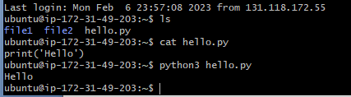

B.

